Eadock01@louisville.edu

Assignment # 2

Eric Arlan Dockery 09/23/2013

09/23/2013

Programming Assignment 2

By: Eric Dockery

P.P 3.1 Write an application that prompts for and read’s the user’s first and last name (separately). Then print a string composed of the first letter of the user’s first name, followed by the first five characters of the user’s last name, followed by a random number in the range 10 to 99. Assume that the last name is at least five letters long. Similar algorithms are sometimes used to generate usernames for new computer accounts.

For this problem I will need to import java.util.\* for random number generation and for the Scanner(System.in) functions. Also I will need to use the String.substring (int, int) Function to get the parts of the first and last name correctly. The First name will have the integers (0,1) and the last name will have (0,5) then I will concat the function together in order to get the appropriate username generated. Even though we haven’t talked about it in lecture since we are taking input from the user we should close out the scanners at the end of the program using the .close() command.

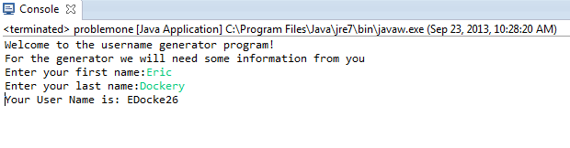

P.P 3.6 Write an application that reads the lengths of the sides of a triangle from the user. Computer the area of the triangle using Heron’s formula (below), in which s represents half of the perimeter of the triangle and a,b and c represent the lengths of the three sides. Print the area to three decimal places.

Area= SQRT(s(s-a)(s-b)(s-c))

To write this program we will need to use scanners to get the sides of the triangle from the user. We will also need to use the formula for the perimeter of a triangle which is s = a +b +c. After calculating the perimeter we will then use the area formula above and the java function sqrt() to calculate the area and report the finding back to the user.

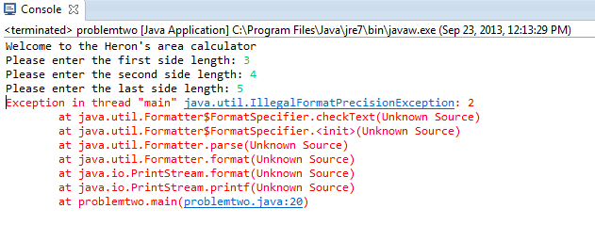

Invalid form of limiting the floating decimal to two places. Placed an extra % symbol in the code.

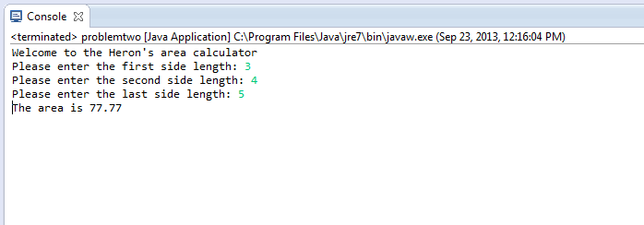

P.P 3.7 Write an application that generates a random integer in the range 20 to 40, inclusive, and displays the sine, cosine, and tangent of that number.

To program this we need to look up the functions for sin, cos, and tan in the math library. These functions are just Math.sin(double), Math.cos(double), and Math.tan(double). So we use those functions and the random function to generate the angle and its values in radians.

